ACM Word Template for SIG Site

First Author¹, Second Author², Third Author³, Fourth Author⁴ and Last Author⁵
Authors’ Affiliation
¹First author’s email, ²Second author’s email, ³Third author’s email, ⁴Fourth author’s email, ⁵Fifth author’s email

ABSTRACT
This set of guidelines for formatting your research paper has been adapted from the formatting guidelines for ACM SIG Proceedings. The Abstract should consist of 150 to 250 words in a single paragraph that provides the reader with a summary of your research/project and what you intend to do. It gives a brief description of the motivation for your research/project, the problem you intend to cover, the purpose and method for conducting your study, and your results and findings.
Keywords
Give three to four keywords relevant to your research/project, e.g., Data Warehouse, ETL, OLAP, Query Processing, Query Optimization.

Introduction
Conference proceedings and journal publications usually ask authors to follow a set of guidelines to make the paper appear of high quality. Some of our courses require students to adapt these guidelines to prepare them for publishing their work. Thus, it is mandatory that you ensure your research / technical paper look exactly like this document. The easiest way to do this is to simply download a copy of this document and type-over the contents with your own material. Do not change any formatting or introduce your own style.

Basic Elements
Most publications contain a number of basic elements, such as the Title, Authors List, Abstract, Figures/Tables/Listings, and References. Use the given format in writing for Title, Authors List and Abstract. Do not change or introduce your own format.

Figures, Tables and Listings
Place tables, figures and code listings as close to the text where they are referenced as possible. If necessary, a table, figure or code listing may extend across both columns to a maximum width of 17.78 cm (7”).
Figures, tables and listings should have captions. The captions are in Times New Roman 9-point bold. They should be numbered (e.g., “Table 1” or “Figure 2” or “Listing 1”). Note that the word for Table and Figure are spelled out.
Figures are used to refer to diagrams, pictures and charts. A figure’s caption should be centered beneath the image or picture, as illustrated in Figure 1.
Tables are used to refer to columnar data such as test results. A table’s caption should be centered above the table body as shown in Table 1.
Listings are used to refer to algorithms or pseudocodes, code snippets, text excerpts, and text output from executing a code. A listing’s caption is placed left-justified above the listing as shown in Listing 1.
Further note that we refer to figures, tables and listings as “Figure x”, “Table x”, and “Listing x”, where x begins from 1. Avoid using prepositions like “above” and “below”.
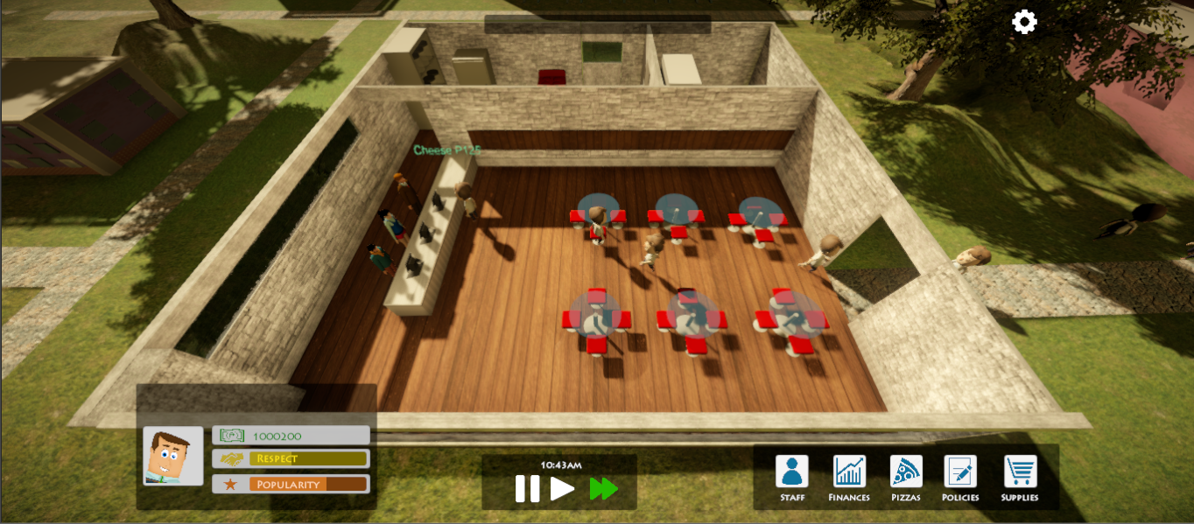
Figure 1. Main interface of Pizzeria [10]
Table 1. Table captions should be placed above the table
Survey Item | Rating 1 | Rating 2 | Rating 3 | Rating 4
Item #1 | N (%) | N (%) | N (%) | N (%)
Item #2 | N (%) | N (%) | N (%) | N (%)
Listing 1. Story excerpt from Picture Books 1 [7]
The evening was warm. Rizzy the rabbit was in the dining room. She played near a lamp.

Footnotes, References and Citations
Footnotes should be Times New Roman 9-point, and justified to the full width of the column.
Citations in ACM publications follow the numbered format, e.g., “Forman [4] reported that …”, “In the study of Bowman, Debray and Peterson [1], …”, “Ding, and Marchionini [3] used …”, “… as described in [2]”, and “Pizzeria [10] is an interactive storytelling environment that…”. Notice also the varying ways by which we can cite different related works.
Use the “ACM Reference format” for references – that is, a numbered list at the end of the article, ordered alphabetically and formatted accordingly. See examples of some typical reference types, in the new “ACM Reference format”, at the end of this document. Microsoft Word may try to automatically ‘underline’ hotlinks in your references; the correct style is NO underline.
The references are also in Times New Roman 9-point, but that section (see Section 4) is ragged right. References should be published materials accessible to the public. Internal technical reports may be cited only if they are easily accessible, e.g., some Universities and research labs provide copies of their manuscripts as technical reports. Arxiv is also another popular venue for citing technical papers. Proprietary information may not be cited. Private communications should be acknowledged, not referenced (e.g., “[Robertson, personal communication]”).
The following are some guidelines in helping you come up with correct references:
- Follow the stated format required by a particular publication. For example, some publications require the full name of the authors to be stated while others only require the lastname, followed by the initial of the firstname.
- For publications sourced from ACM, IEEE and Springer, you can use their “cite as” feature to get the complete publication details, including the publication title, the page numbers, and publisher name.
- Section 4 provides some example publications. Determine which of the examples closely match your reference, then use that example publication format. For instance, use [1] and [4] for journal publications; [7] for conference papers that are published in conference proceedings; [3] for technical reports; [9] for a book reference while [8] and [10] for articles or chapters in a book; and [6] for a thesis document. In case a thesis has been published, cite the publication instead. [5] shows an example of citing an online article from a reputable organization
- Newer publications may also include doi. You can indicate those after the publisher details as shown in [2].

Technical Report Content
The sections for your Technical Report are described in the corresponding project specifications found in AnimoSpace.
To use this ACM paper template, replace each section with the required section heading as indicated in the project specifications. For example, for MCO1, the sections are:
1. Introduction
2. Data Warehouse
3. ETL Script
4. OLAP Application
5. Query Processing and Optimization
6. Results and Analysis
7. Conclusion
8. References
9. Declarations
You may optionally include an Appendix to show your code snippets, SQL statements, sample extract of the dataset, and sample query results.

References
- Bowman, M., Debray, S. K., and Peterson, L. L. 1993. Reasoning about naming systems. ACM Transactions on Programming Languages and Systems, 15, 5 (Nov. 1993), 795-825.
- De Nieva, J.O., Joaquin, J.A., Tan, C.B., Te, R.K.M. and Ong. E. 2020. Investigating Students Use of a Mental Health Chatbot to Alleviate Academic Stress. In Proceedings of the 6th Interna- tional ACM In-Cooperation HCI and UX Conference. Association for Computing Machinery, New York, NY, USA, 1–10. https://doi.org/10.1145/3431656.3431657
- Ding, W. and Marchionini, G. 1997. A Study on Video Browsing Strategies. Technical Report. University of Maryland at College Park.
- Forman, G. 2003. An extensive empirical study of feature selection metrics for text classification. Journal of Machine Learning Research, 3 (Mar. 2003), 1289-1305.
- Mental Health America. n.d.. Mental Health Treatments. Mental Health America. https://www.mhanational.org/mental-health-treatments
- Sannella, M. J. 1994. Constraint Satisfaction and Debugging for Interactive User Interfaces. Doctoral Thesis. UMI Order Number: UMI Order No. GAX95-09398., University of Washington.
- Solis, C.J., Siy, J.T., Tabirao, E. and Ong, E. 2009. Planning author and character goals for story generation. In Proceedings of the NAACL Human Language Technology 2009 Workshop on Computational Approaches to Linguistic Creativity, Boulder, CO, pp. 63-70. Association for Computational Linguistics.
- Spector, A. Z. 1989. Achieving application requirements. In Distributed Systems, S. Mullender, Ed. ACM Press Frontier Series. ACM, New York, NY, 19-33.
- Tavel, P. 2007. Modeling and Simulation Design. AK Peters Ltd., Natick, MA.
- Yu Galan S., Ramos M.J., Dy A., Kim Y. and Ong E. 2017. Towards a narrative-based game environment for simulating business decisions. In Interactive Storytelling, N. Nunes, I. Oakley, V. Nisi (eds). ICIDS 2017. Lecture Notes in Computer Science, 10690. Springer, Cham, 290-294.

A. Appendix
Some conference papers include an Appendix where authors can place supplementary materials.
For our Technical Report, supplementary materials may include code snippets, SQL statements, sample extract of the dataset, and sample query results. These are used to help your readers better understand your implementation and your discussion.
Note that in the appendix, sections are lettered, not numbered.

